Contents
Background 1
Configuration 1
Complete Balance Period End 3
Complete Balance Recalculation 5

Background
At the end of the balance/holiday year the Balance Calendars must be closed to:
- Calculate new entitlements
- Apply Length of Service Adjustments
- Process carried forward valued
 | NB: The University of Oxford configuration is currently for all balances to have zero days leave carried over and any agreed carry over to be input by HR teams in the new holiday year.

Prerequisites:
System Calendar is up to date (see How To – Maintain calendars in WFM).
Balance Calendar exists (see How To – Maintain calendars in WFM).
Balance Calendar has been extended to at least one future balance period (see How To – Maintain calendars in WFM).
Entitlements Length of Service values up to date.
Balance Calendar period is complete e.g. to close 2021 (1st Oct 2021 – 30th Sep 2022) date must be in next period i.e. 2022 (202240) 3 October 2022).
Relevant reports have been run by HR Admin’s of the outstanding leave balance for individuals before the rollover begins, so that leave carry over can be calculated and input. (Report TIMDEP02 Leave balance History per Employee can be used for this purpose).
To complete this function menu profile WFM_BALANCE_PERIOD_END must be assigned to the individual portal user via Security > User Management.

Configuration
The following PeopleXD configured menu profiles have been made available providing the functionality:
WFM_BALANCE_ADMIN
WFM_BALANCE_PERIOD_END
WFM_ADVANCE PERIOD

Alternatively, the following menu options can be enabled separately against an existing HR Systems menu profile:
Menu Option | System Area
CorePortal - Workforce Management Admin | CorePortal
Balance Maintenance | CorePortal
Balance Activation | CorePortal
Balance Period End | CorePortal
Balance Recalculation | CorePortal
Get roster | Web Services
Get bytype | Web Services
Create settings balances activate | Web Services
Create settings balances periods end | Web Services
Create settings balances recalculate | Web Services
Get access user department | Web Services
Get access user workgroup | Web Services
Get settings balances | Web Services
Get settings balances activate | Web Services
Get settings balances errors | Web Services
Get settings balances history | Web Services
Get settings balances linked | Web Services
Get settings balances periods | Web Services
Get settings balances periods end | Web Services
Get settings balances recalculate | Web Services
Get settings global | Web Services
Update settings balances history ignore | Web Services
Update settings balances history ignore Proxy (Entire Organization) | Web Services
WFM Admin | CorePortal
WFM Configuration | CorePortal
Roster | Web Services
Advance Period | CorePortal
Advance Period - Transfer Access | CorePortal
Get companies calendars | Web Services
Get companies exceptions | Web Services
Get companies transferaccess | Web Services
Update companies calendars period | Web Services

Complete Balance Period End

 | NB: To complete this process menu profile WFM_BALANCE_PERIOD_END is required.

- Login to PeopleXD
- Navigate to the WFM Admin Dashboard > Balance Maintenance

- The Balance Maintenance screen displays all the existing balances, the current balance period, balance type and the number of employees assigned.

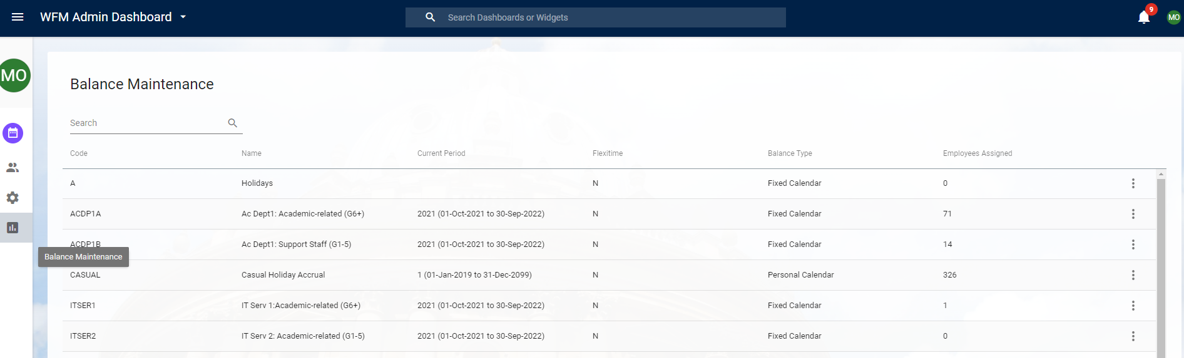

- For the relevant balance select ‘View’ from the ellipsis (3 dots on the right of the screen).

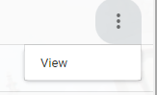

- Select the Balance Period End tab from the left hand side.

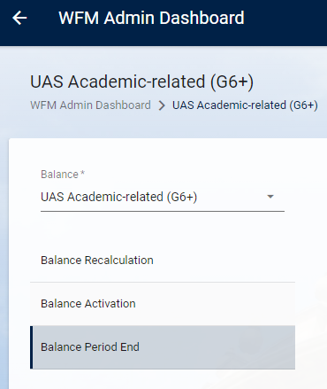

- On entry to the screen the current balance period details are displayed.

- For the Balance Period End process ensure the filter is set to return ALL records.

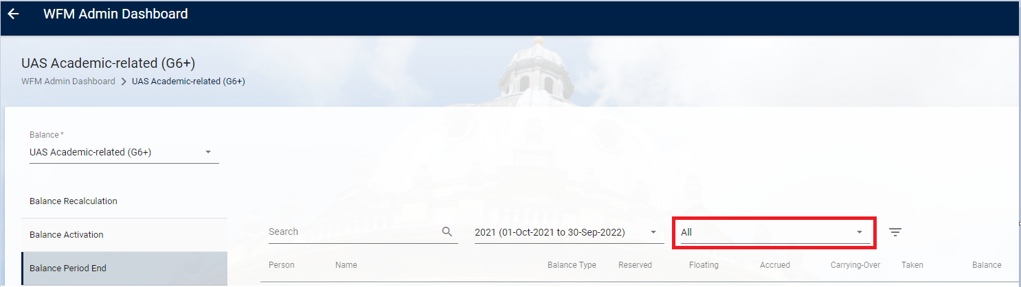

- Select Run Period End



- A message displays explaining that this will end the current period for the balance selected. To continue with the balance period end process select YES.

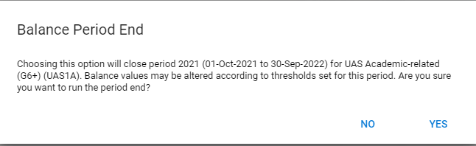

- The Run Period End button at the bottom right of screen changes to Running Period End.

- Once the process has finished, you will see Complete at the bottom of the screen.

Complete Balance Recalculation

Once the Balance Period End has been completed there is an overnight process, which calculates the balances for employees. Depending on when the period end has been completed you may need to force a Balance Recalculation. Use the following steps for this purpose:

- Login to PeopleXD

- Navigate to the WFM Admin Dashboard > Balance Maintenance

- The Balance Maintenance screen displays all the existing balances, the current balance period, balance type and the number of employees assigned.

- For the relevant balance, select ‘View’ from the ellipsis (3 dots on the right of the screen).



- Select the Balance Recalculation tab from the left hand side.

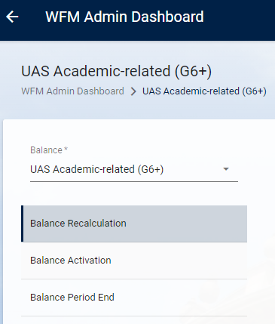

- Select the From Period for your balance.
- Choose what you want to recalculate, i.e. Balance Values, Booked Values or Both. If recalculating to force the update after the period end select Both.

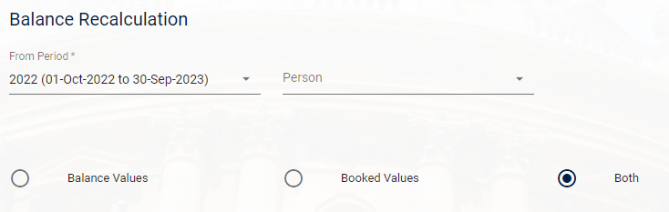

- Click ‘Recalculate’.
- Select Yes to the confirmation message.
- Repeat these steps for each balance that has been rolled to the next period.

